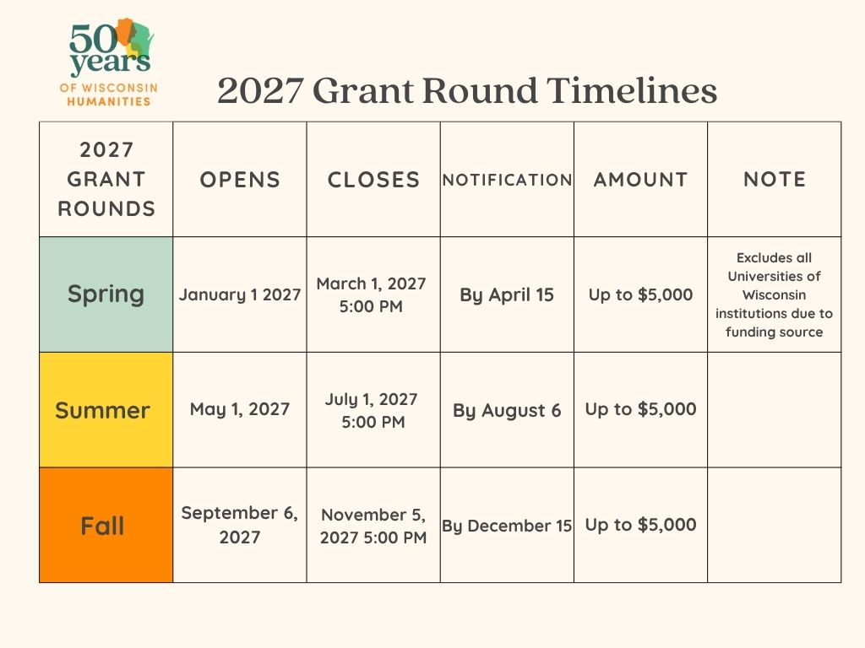

2027 Grant Application Instructions

The best place to start reviewing our grant program is our website. Please review the grant pages at our website, www.wisconsinhumanities.org for resources and details. Two January application assistance sessions (via Zoom) have been scheduled and more will be offered for remaining rounds. Bring your questions or an area you want to talk over and register for either session. Registration links are at our website. We also have a 8 minute video covering basic eligibility/requirements at our website.
Schedule a phone or virtual consultation if you’d like to discuss grant requirements or have questions. Contact Meghan Dudle at meghan.dudle@wisconsinhumanities.org or call 608-265-5595

CREATING AN ACCOUNT

Wisconsin Humanities has moved ALL grant application activities to an online portal. All materials should be submitted at the time of application using this portal. Find the link to the online portal at our website: www.wisconsinhumanities.org

First-time users of our grant application portal will need to create an account. You will first be asked to create an organization identity for the Fiscal Sponsor Organization. This is the organization to whom a check will be written if you receive a grant. If your organization cannot receive funds on its own behalf, be sure to create your account using your Fiscal Sponsor Organization’s information. In this case, you will also use the field called Programming Organization. For example, if you are a library that is fiscally attached to a municipality, the Fiscal Sponsor Organization is the municipality.

To create an account and to apply for WH funds, the Fiscal Sponsor Organization must:
- provide a Wisconsin-based Tax ID (EIN)
- provide a Unique Entity ID (SAM)

*Enter placeholder numbers for your UEI (SAM) if you do not have it yet so you can keep moving in the application. Request your UEI as soon as possible, as you need that UEI number by the decision date (notification date) or you will not be funded.
- be a nonprofit organization or group located in Wisconsin.

This UEI number is required to receive a WH grant and you must receive it by the grant decision date. Unique Entity ID (SAM) or UEI (SAM) is a federal government-issued authoritative identifier. Organizations that have an active or inactive registration in the federal government's "System for Award Management" already have been assigned a UEI (SAM) and that ID is viewable on the organization’s registration record at https://sam.gov/content/home
SAM.gov | Home Go to this link to request a UEI (SAM)
Information needed to get a Unique Entity ID include:
- The entity’s legal business name and physical address. A post office box may not be used as your physical address.
- The system may also ask for your date and state of incorporation for entity validation. Some entities may be asked to provide additional
- business documents to establish their identity
- After entering information about the Fiscal Sponsor Organization, you will provide your contact information and email to create a login account. The person who creates the account will be the primary contact and will receive important emails from the WH Grant Administrator. Only use an email account that is checked regularly.
Once you have created your account you will be taken to your “dashboard.” Choose “apply” to see all open grant rounds and to begin an application. While viewing a grant description you can “preview” the application form and create a PDF of the questions.

GENERAL INSTRUCTIONS AND BASIC INFORMATION
We recommend composing your answers to the project proposal description in another document, then cutting and pasting into the application form. Please note there are character limits for each section. You may save without submitting your work to come back later.

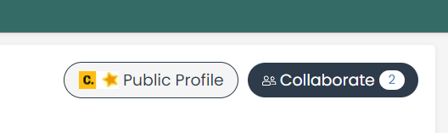
If you need to collaborate with other team members, the “collaborate” button in the upper right- hand corner of the page will allow you to share the application.
In an application, you can also create a PDF of your application packet to print from your device.

Forms that will be uploaded into the application include:
+ Budget Form +W9 Form +Certification Form
These required forms are available for download at our website at the FORMS & RESOURCES page.
Project Title. This should be a descriptive title – preferably the title you will use in your public communications about your project.
Project End Date. The project period begins with the award of the grant. The project end date is the date by which you will have incurred or legally encumbered all project expenses. The date you select should be some time after the date of the last public program. Within 90 days after this date, WH grantees are required to submit final financial and program reports.
Amount Requested and Matching Funds should reflect the totals from the itemized budget form. The amount requested should be rounded down to the nearest dollar and not exceed the grant’s maximum amount. The total amount of your matching funds must be equal to, or greater than, the total amount you are requesting from Wisconsin Humanities and should be rounded down to the nearest dollar.
Project Director. The Project Director is responsible for directing the proposed program and submitting the final report. The Project Director and the Fiscal Agent cannot be the same person. We must have information that will allow us to directly contact the Project Director if we have questions about the proposal or a granted project.

ORGANIZATION INFORMATION
Programming Organization. When another organization is serving as the fiscal sponsor, this is the organization coordinating and carrying out the project. For example, Your Library may be the Programming Organization, but Your City is the Fiscal Sponsoring Organization connected to the Tax ID.
Organization Information. (Character limit 1,000) Describe the organization that is implementing
the proposed project: its mission, activities, and public programs.
Organization or Project Website. Enter the URL of the programming organization and/or the project, if applicable. Under the “Supporting Materials” section there is a space to add additional URLs if appropriate.
County. This is the county in which the Fiscal Sponsor Organization is located.
Congressional, State and Legislative Districts: List the Congressional and Legislative district numbers where the Fiscal Sponsor Organization is located. District information can be obtained from the Wisconsin State Legislature (https://legis.wisconsin.gov/).
The Fiscal Agent is the person responsible for maintaining financial records of grant expenditures and submitting financial reports to WH. We must have information that will allow us to directly contact the Fiscal Agent if we have questions about the proposal or a granted project. The Project Director and Fiscal Agent may not be the same person.
SAM.gov (System for Award Management)
*Requesting and receiving a UEI number (SAM) is mandatory if you do not already have one. You will not be funded without this UEI #. It is required to have the number by the award notification date.* SAM.gov registration is, however, strongly encouraged. If the fiscal sponsor organization does not have full SAM.gov registration, this will not affect your eligibility to receive a WH grant.
There is no charge for SAM.gov (or UEI (SAM) registration). Several third-party vendors, however, offer to register organizations for a fee, which can be substantial. WH does not endorse these vendors or the use of their services for SAM.gov registration. If a WH grant is awarded, organizations registered with SAM.gov at the time of their application should keep that registration active for the duration of their project period.
For SAM.gov registration and information, please go to System for Award Management (https://sam.gov/ content/home), or you may go directly to the registration page at SAM.gov here: https://sam.gov/content/ entity-registration.
Remember, you can register to bid and apply for federal awards (what we are calling full registration) OR you can request a Unique Entity ID only without having to complete full registration.
PROJECT DESCRIPTION Your project description should demonstrate a firm grasp of the subject matter of your project, an ability to organize and carry out the project, and clearly defined roles for your humanities personnel. If your project description intrigues reviewers, they are likely to think that your project will interest your target audience, too. Write your description in a straightforward style, without jargon. Please avoid repetition between sections. If your project is primarily for a website, film, podcast, or other digital project, you will only answer the first two bullet points below and then move on to the specific digital project questions detailed later in this document.

  - Project Description. (Character limit 7,000) Describe your project. Include research, planning, and public programs. In your descriptions, please address the following:
    - Provide a preview of the subject matter you will be sharing with participants. Help us understand the ideas your project explores.
    - What are two or three of the questions that your project addresses?
    - What format and venue will you use for your public program(s)?
    - How will this format help your participants engage with the subject matter?
  - Project Goals and Objectives. (Character limit 4,000) Why is your organization developing this project? What need or interest in the community are you intending to address? What goals have you set for the project?

  - Project Promotion/Audience (Character limit 4,000) What audience(s) does your project serve? How will you publicize the project to your intended audiences?

  - Project Partners. (Character limit 4,000) Describe the organizations with which you are collaborating on this project and why. What are their roles? Cite established or new organizational partnerships.

  - Humanities Personnel (Character limit 4,000) For each key humanities personnel and the project director, it is REQUIRED to list the following. Please number your answers as seen below for each person. We do not need the above information for people with technical (E.g. web designer) or administrative support.
- Name & Email
- Specific role(s) of the person in your program activities, planning or content:
Limit to 2-3 sentences.
- Current Employment and/or organizational affiliation
- Describe briefly the background, knowledge, lived experience and/or education that qualify this person as a resource for the project or program. Use the humanities personnel description at our website for guidance.

CALENDAR/TIMELINE
Calendar of Events. (Character limit 3,000) As much as possible at the time of application, describe the location, date, and time of all planned public programs. Please list only those events that occur within the defined project period! If a grant is awarded, project directors must later submit events to a web form with confirmed specifics for each public program.

BUDGET
Your project budget is as important as your project description. Make sure that the activities you describe are accounted for in your budget. Likewise, make certain that every item in your budget relates to an activity described in your project description. Your budget should represent actual expenses (not any income) related to your project. Please do not inflate your budget and remember to check your math.
The project budget has two parts: the budget form and the budget description. You must complete both. For specific rules and regulations for fiscal administration of the grant, recipients should consult our WH Grant Guidelines, Terms and Conditions available on the WH website at the FORMS & RESOURCES page.
Matching Funds. Wisconsin Humanities grants require matching funds that are equal to or greater than the amount requested from WH. Matching funds may be cash or in-kind. They include any known sources of grants or gifts, any in-kind contributions, and any sources of revenue, such as admission fees. All anticipated income from fees must be shown in the expenditure budget as part of the matching funds and must be explained. Examples of in-kind match include the dollar value of facilities, services, talents, and time contributed to the project.
Expenses. All WH funds and matching funds must be directly attributable to the project. All WH funds and most matching funds may only cover costs incurred or legally obligated during the project period, after a funding decision is made until your project end date.
Expenses incurred in preparing your proposal—such as the value of your time—may, however, be counted as matching funds.
Eligible Expenses WH will fund reasonable project related expenses such as:
- Honoraria for humanities experts
- Individual staff salaries related to project implementation
- Per diem and travel expenses for project personnel
- Printing and publicity
- Facility rental
- Materials necessary for the project
- Indirect cost (Either the appropriate federal NICRA rate or de minimis 15% rate)

Ineligible Expenses WH will not fund:
- Capital expenditures
- Expenses related to fundraising
- Expenses related to an archival project
- Museum acquisitions
- Re-granting of WH funds
- Gift or gas cards
- Alcohol

As defined by Wisconsin Humanities, capital expenditures are funds used to purchase equipment or material that will have a significant working life after the end of the grant project period.
If you have questions about the eligibility of a particular item, you are encouraged to consult with WH staff before submitting your proposal.
Budget Form: Download and use the budget form linked from the application to complete your budget. The budget form is also at our website. Please do not use any other budget form.
Upload the completed form into your application in the specified place.

Completing the Columns
- In the “WH Request” column, itemize your request for WH funds.
- In the “Matching Funds” column, itemize the cash and in-kind expenditures for your project that are not part of your WH request. Do not include any cash or in-kind costs that have been, or will be, counted as match on any other award of federal funds. Remember that the total amount of your matching funds must be equal to, or greater than, the total amount you are requesting from WH.
- In the “Total” column enter the total of the first two columns.
- Copy the totals for the two columns—WH request and Matching Funds— into the corresponding fields in the General Instructions and Basic Information section.

Personnel
List expenses individually for each participant. List the amount of time each participant will spend on the project and calculate the value of that time, using his or her basic salary or wage as a measure. For example:

Project Director: 5% time for 3 months @ $35,000 per year = $437.50; or 15 hours @$20/hour = $300

The following suggested payment scale reflects a variety of roles commonly played by project scholars. These figures are not fixed rates. Justification for payments of more than $1,000 per day must be provided in your budget description.
Moderator: $100 to $200 (2-3 hours) Panelist: $200 to $500 (2-3 hours) Lecturer: $300 to $1,500
Humanities Personnel/Scholar: $500 to $2,000 (full day/program) (A limit of $300 per day is recommended for scholars participating in programs on their own campuses.)
Nationally known humanities personnel/scholars: negotiable

Individual staff salaries related to project implementation are eligible for WH funding, or the value of staff (and volunteer) time spent on project activities may be counted as matching fund expenditures.

Travel, Food, and Lodging
List expenses individually for each participant.

WH will not pay for the purchase of alcoholic beverages.
We recommend that applicants use the State of Wisconsin travel regulations in determining your budget. Currently, State of Wisconsin rates for travel, food, and lodging are based upon federal rates published on the federal U.S. General Services Administration website: https://www.gsa.gov/travel/plan-book/per-diem-rates/
Personal auto mileage: $0.70/mile
Hotel lodging for all Wisconsin locations without a specified rate:
$110.00/ night
Per diem for all Wisconsin locations without a specified rate: $68.00/day
Counties in Wisconsin with specified rates include Columbia, Dane, Door, and Milwaukee. See the GSA website for information on rates for these counties. These rates may be subject to change.

Hospitality
WH will only pay for food when it directly contributes to the success of the program. We will consider modest requests for food if it can be argued that serving a meal will encourage the participation of a particular audience or otherwise contribute to the program in a substantial way. We will not pay, for example, for a reception celebrating the opening of an exhibition. We will not pay for the purchase of alcoholic beverages.

Supplies and Services
These must be directly related to the proposed project. Itemize all supplies. For example: 1,000 brochures @ $0.10 each = $100
Equipment Rental: WH will not ordinarily fund equipment purchases of items costing over $500. We may, however, pay for the rental of such equipment if doing so makes economic sense.
Facility Rental: The value of donated space should be included under matching funds. WH funds should not be requested for facility rental except when the applicant is paying a fee for the use of a program venue.
Indirect Costs
Institutions that have a current federally Negotiated Indirect Cost Rate Agreement (NICRA) may use that established indirect cost rate in their proposal budget and may list this indirect cost as either a WH-funded expense or as match. A copy of the NICRA should be submitted with applications for funding. Also note that costs included in the NICRA should not additionally be listed as separate expenses in the proposal budget.
For organizations that have never had a NICRA (and are NOT a state or local government, or Indian Tribe receiving more than $35 million in direct federal funding) may alternatively use a de minimis rate of 15% of modified total direct cost (MTDC) in their budget proposals. This rate can be placed in either the matching fund column or the WH request column. Please note that rental costs are excluded from the 15% calculation. For more information on indirect costs please consult WH staff.
Budget Description. (Character limit 4,000) The budget description is your opportunity to explain the details of your budget.
- Describe the cash or in-kind sources of all matching funds. List your sources of matching funds and what each source is contributing as either an amount of cash or the value of in-kind services. Note which matching funds have been secured and which are still pending.
- Describe the rates and formulas used for figuring donations of personnel time and indirect costs.
- If you are charging admission or registration fees, describe the amount per person, the total you expect to collect, and what you plan to do with any surplus. WH strongly encourages the use of scholarships, free admission days, and other flexible admission policies that make WH-funded projects accessible to participants for whom a fee could present an obstacle.
- Explain any other aspects of your budget that need clarification, such as a request for personnel costs (other than honoraria), particularly high honoraria, equipment purchases, and specific supplies.

CERTIFICATIONS
W-9 Form. (3 MiB limit) An IRS W-9 Request for Taxpayer Identification Number and Certification form should be completed, signed, and uploaded with your application for WH grant funding. The name and Tax ID number on the W-9 form should match the name of the Fiscal Sponsoring Organization that is applying for funding. Award checks will typically be
sent to the address listed on the W-9 unless other arrangements are made with WH. To keep file sizes small, only the first page with the signature on it needs to be uploaded.
Certifications. (2 MiB limit) To be eligible for proposal consideration, each application must include a signed certifications form. Download the form from the application. Both the Project Director and the Fiscal Agent must sign this form acknowledging the statements on the form. Please note that this signed form also certifies the participation of project personnel identified and described in the humanities personnel section.
The signed form should be uploaded to the application in the space provided. If you cannot acquire both signatures at the time of submission or have technological limits to uploading this document, you may email it to Meghan.dudle@wisconsinhumanities.org or mail a paper copy to our office. We prefer to not receive photographs of the form. Wisconsin Humanities must receive the form with signatures from the Project Director and Fiscal Agent within two weeks of the grant application deadline for the proposal to remain eligible.

SUPPORTING DOCUMENTS
Provide only those supporting materials that are directly relevant to your project. These two fields are optional and may not apply.
Additional Supporting Materials. (8 MiB limit) This section allows you to upload relevant materials that are necessary to understanding the project. These might include a schematic or mock-up of an exhibit or a photograph that more clearly conveys your project.
Additional Supporting Materials Weblink. Alternatively, you can provide a link to further information contained at a website, dropbox or shared drive. This is a place, as well, to include links to video trailers for film projects, or sample work for digital projects.

AUDIO, VIDEO, AND DIGITAL PROJECTS
Wisconsin Humanities funds digital humanities projects such as short videos, full-length film documentaries, websites, video games, podcasts, and other audio projects. Digital projects may also be part of a larger project such as an exhibit, or the cumulative effort of a larger humanities-based program. A digital humanities project should not be strictly archival. Instead, it must engage the public and be publicly accessible.
Projects that can be described as “digital humanities” may prompt special project and budget considerations. For example, Wisconsin Humanities considers requests for computer hardware and software as part of a digital humanities project. Their intended use must, however, be clearly described for the project period and beyond and must be demonstrably vital to delivering humanities content.

Digital humanities projects such as online exhibits can expand traditional definitions of “audience,” “public,” and “community engagement.” Applicants should thoughtfully consider and clearly describe the audiences for the project, as well as the nature and duration of the proposed public engagement. For example, if your proposed project is a website, you must describe your plans to maintain it.

If the project you seek funds for is primarily to develop a website, digital game, film or podcast you should answer the digital humanities questions on the application. (Character limit 6,000)
- Provide a treatment that describes the structure, theme, style, format, voice, and point of view of your project.
- When available provide a script/scenario.
- Please include a justification for this format and the distribution plan for this project.
- Use the supporting materials section to provide a link to sample work.

SUBMISSION AND REVIEW
Submission. When you are ready to submit the application, you must click “submit” prior to the 5:00 PM deadline.The electronic system will not allow you to submit after a deadline has passed and we will not open the round again if you miss the deadline. You will receive an email acknowledgment if you have successfully submitted the application. Please monitor email from Wisconsin Humanities. If there is some part of the application that is not complete, we may push the application back to you to seek additional information or a correction to a form. A missed deadline may lead to a proposal being deemed ineligible or reviewers may decide they do not have the confidence to grant the funds based on unanswered questions.
Review. These grants are reviewed by members of our board. Please refer to the criteria at our website for more information.
Decision. Decisions are made about 1 month after the deadline.
You will receive an email notifying you that your grant request has been approved or denied. If your proposal is approved, you will receive follow-up emails providing instructions about your grant award.

